**best fast food mac cheese kfc chick fil popeyes Boston market 800 S4**

**Introduction:**

Mac and cheese are also one of those rare dishes whose industrial version, orange cheese, and everything, often taste better than their handmade versions. It's because of fondness for highly processed products that are intended to be more addictive, that it feels like a missed opportunity that more restaurants, such as Chick-fil-A, aren't providing mac & cheese alongside their fries and nuggets.

To determine which fast-food joint offers the best fried chicken sandwich, Popeyes, Chick-fil-A, and Wendy's are competing online and in person. Over a different traditional comfort dish, a new food war may be starting.

**The Mac & Cheese war:**

**Earlier last month, Chick-fil-A added mac & cheese to its standard menu. KFC quickly adopted this strategy and unveiled new Mac & Cheese Bowls. Boston Market has now joined the fight, offering fans of the gooey, ooey treat 2,000 pounds of the delicious dishThe marketing team also understood that since mac and cheese had been on the menu for some time, they needed to do something ridiculous to raise some eyebrows.**

**The more you spend at Boston Market, the more points you'll earn, and there are ways to earn additional advantages along the way. The first person reach 10,000 points will win the enormous mac and cheese reward, but there are smaller surprises available for less money, including a complimentary little side or a dessert for 30 points.**

The grand prize winner will receive one tonne, or 2,000 pounds, of any Boston Market side. For those who could be lactose intolerant, this could be mac and cheese, mashed potatoes, or sweet potatoes. The winner of the grand prize will either be given a massive plate of the dish all at once or one serving of the prize per day until they are fed a lot of food.

Sadly, it might take some time for fans of comfort food to reach the 10,000-point mark. A customer receives one point for every dollar spent, therefore excluding promotional purchases, you must spend $10,000 at Boston Market to be eligible for the grand prize.

A hint of soul food with a side of mac & cheese makes great sense for brand identification because some of those businesses, like KFC and Popeyes, are known for their southern-style fried chicken. By selling mac and cheese with mashed potatoes, rotisserie chicken, corn, and cornbread, some restaurants, like Boston Market, parody Thanksgiving or family dinner customs. Then there are the fast-casual eateries like Panera Bread and Noodles & Company that dress up the dish with finer cheeses and actual dine-in silverware while serving comfort food for kids in an effort to project a far more upscale image.

Let’s take a look at how each of these restaurant’s Mac and Cheese have performed:

**1) KFC:**

A perfectly acceptable, although basic, fast-food macaroni and cheese. The pasta tends to be mushy, and the cheese can be crunchy at times. The creamy and rich flavor of KFC's mac & cheese complements the company's reputation for producing some of the best chicken in America. Customers have praised mac and cheese so much that KFC added a new dish to the menu called the Mac and Cheese bowl. With a three-cheese mixture on top, this dish blends Kraft noodles with crunchy popcorn chicken.

**2) Boston public market:**

The bright orange mac and cheese from the barbeque restaurant taste quite close to Kraft's original box version. The rotini pasta stands out because they trap the cheese sauce in between their spirals, giving in a satisfying and possibly twisted squish with every swallow. Boston Market offers food that tastes like it was freshly prepared at home and is always hot and ready. In their version of mac and cheese, rotini pasta noodles, which hold more cheese within their spirals, take the place of elbow macaroni. Mac and cheese is the ideal food to serve alongside the flavorful rotisserie chicken from Boston Market.

**3) Chick-fil-A:**

The pasta on the Chick-Fil-A menu rarely disappoints. It is mixed with a parmesan, cheddar, and Romano cheese blend, then baked in-restaurant to ensure it has the essential "crispy top layer." Their mac and cheese is no exception; each order has a different level of enjoyment. This mac and cheese cup has soft macaroni that is covered with a lot of cheesy sauce and a combination of cheddar, parmesan, and romano cheese.

**Conclusion:**

Mac and cheese food war has made all these top food companies notch up a gear and do a special dishes for their customers. Although many claims the mac and cheese from these restaurants are pretty much delicious, some portion of the people prefers eating mac and cheese and smaller restaurants or the homemade mac and cheese. Whether bought outside or made at home, mac and cheese will always continue to make people drool.

**FAQs:**

**1)What are Mac and cheese?**

Mac and cheese is a famous American dish that is made using Pasta and a lot of cheese along with some spices.

**2) Which country invented Mac and cheese?**

Although Mac and cheese is known as an American dish, its origin was in Northern Europe.

**3)Where can I get the best Mac and cheese?**

Many firms claim their Mac and cheese is the world’s best but the choice differs on the taste of people.

**Spinmenot screenshot:**

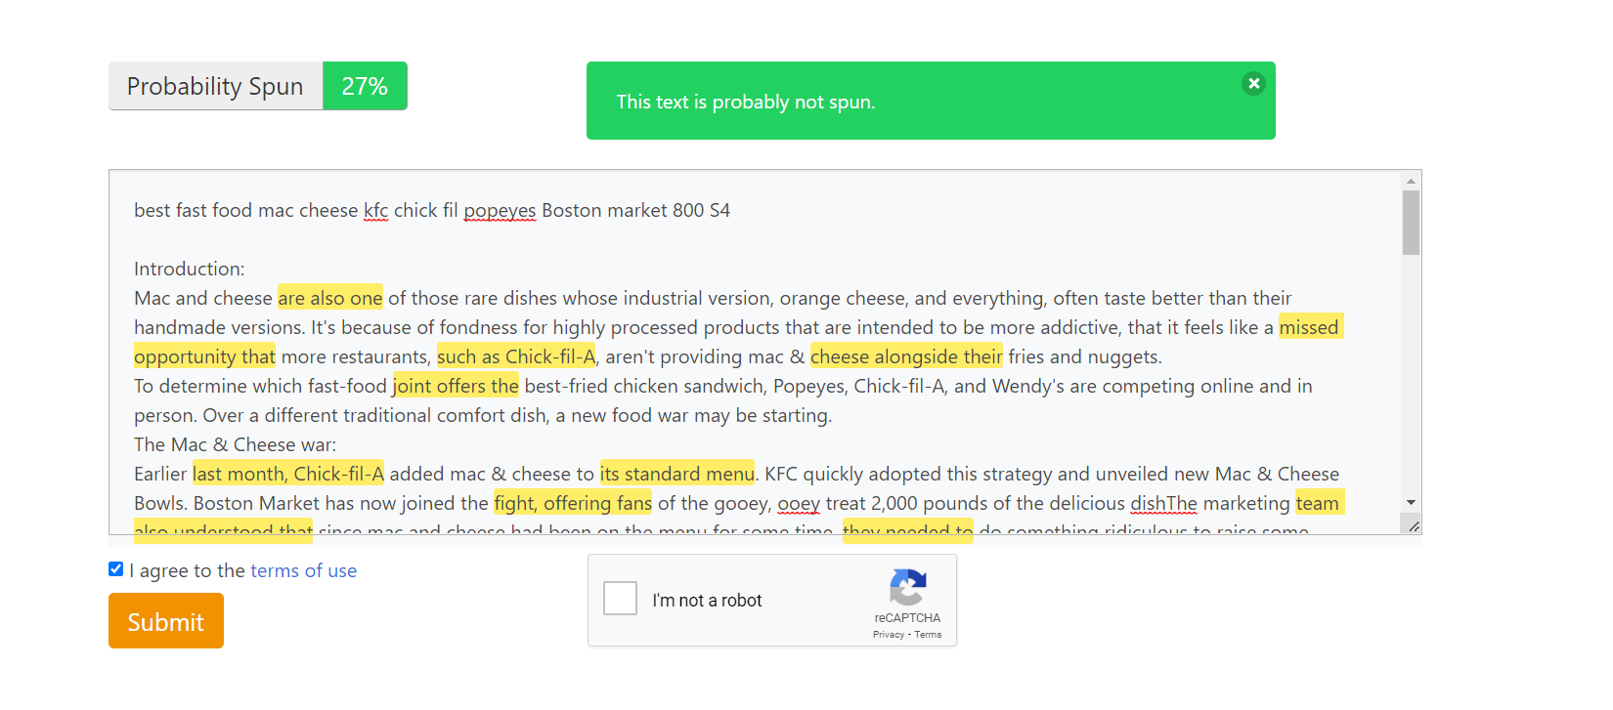

**Grammarly screenshot:**

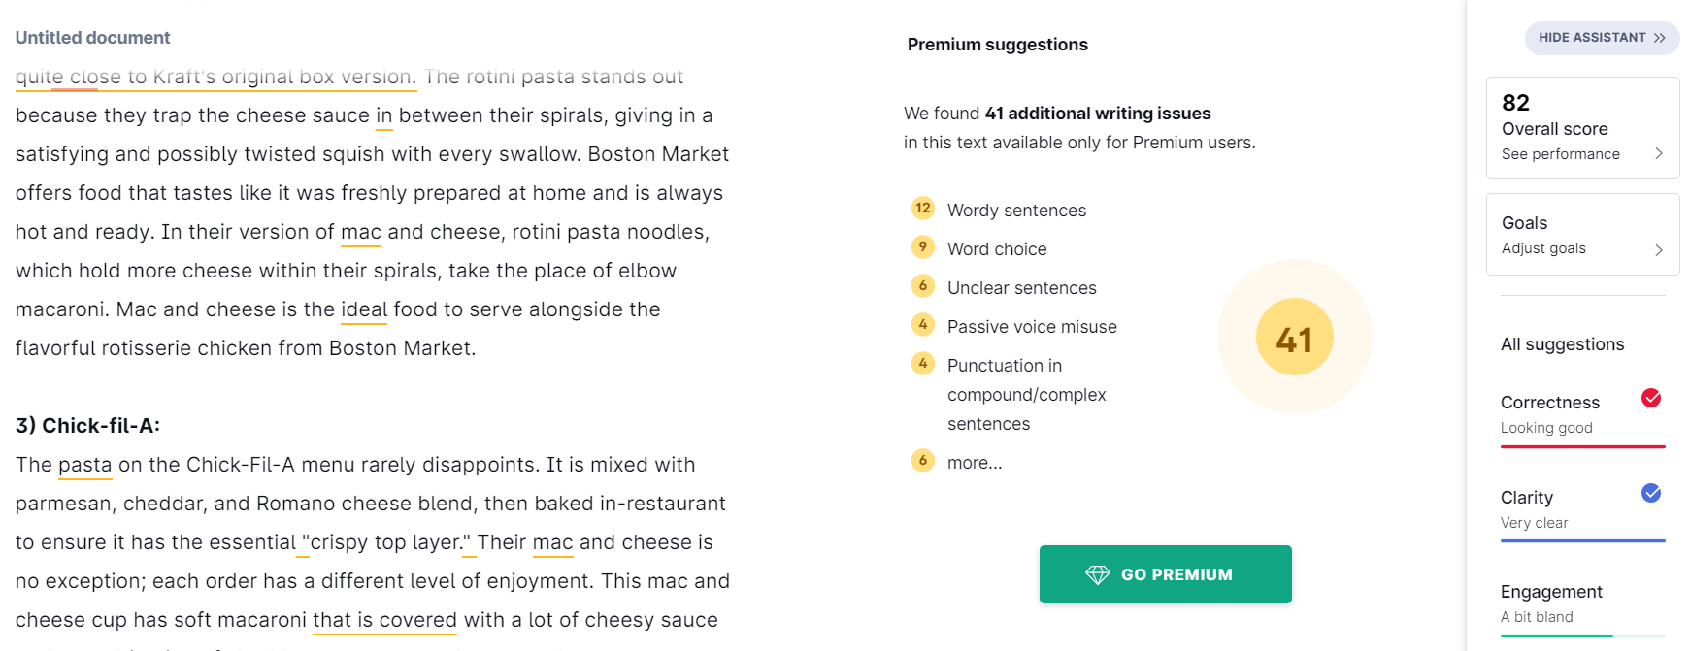

**Quetext screenshot:**

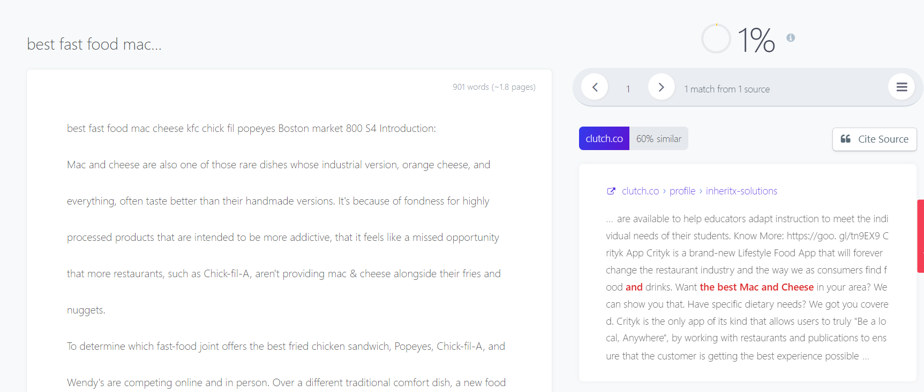

**-An Article by Sanjay M**